Section 9 - Evaluation

Features of Python:
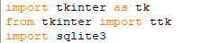
My programmed solution for El Aziz was developed using Python. I chose to write it in Python since it was the language I had the most experience and proficiency in, making it suitable for the project. The choice of python allowed me to use certain external libraries such as tkinter and sqlite3, which helped me form an interactive user interface consisting of buttons, labels and entry fields. This allowed me to gather user input quickly and increase accessibility, allowing users to create reservations or orders anywhere, anytime. Using tkinter, I was able to successfully create an intuitive interface, making the system task easier to manage and complete, and improving efficiency. The use of sqlite3 enabled me to safely store and retrieve data for all stakeholders, quickly and efficiently. This quick access replaced the need for El Aziz staff to take orders on notepads, reducing their workload. SQL allowed me to monitor active orders and reservations, storing and retrieving the persistent data. The data being stored all in one database file optimised storage and access as all data could be found in one location, unlike their current paper based system requiring new notebooks due to large volumes of orders and reservations.
Moreover, using Python allowed me to incorporate exception handling techniques in my program, which optimised my system, preventing it from crashing. For example, in my create order subroutine, when the user inputs a quantity for a menu item, the input is received as a string and must be converted into an integer using ‘int()’. If the user enters an input that is not a number, the conversion would create a value error and cause the program to completely crash. However, I prevented this by placing the conversion into a try and except block. The use of exception handling allows the program to process this error silently, without causing a crash. It displays an error to the user whilst keeping the program running smoothly. Similarly, when logging user logins to the Login logs datable table, the insert statement is placed inside a try and expect block so that if logging fails, it doesn’t prevent the user from accessing their dashboard. This python feature improved the usability and functionality of my program, preventing crashes and keeping users satisfied.
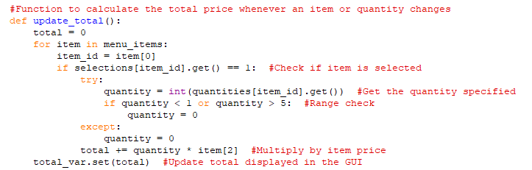

Additionally, the use of Python allowed me to use selection statements in my program to provide more user activity. In my submit login subroutine, I used multiple if statements along with an else statement to determine which database table to query, depending on the role they selected, and their credentials entered. It checked the customers first, then staff and finally admin. This selection statement directed the user to the correct dashboard which was specific to their role. It prevented incorrect dashboard being presented to incorrect users, stopping data exposure form other tables.
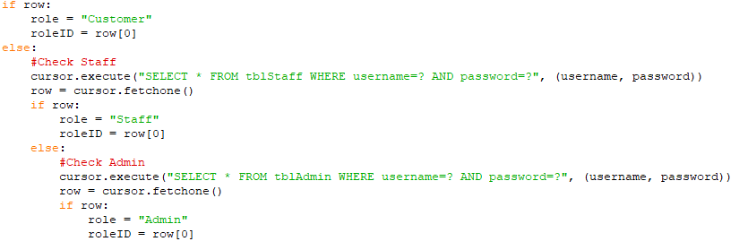

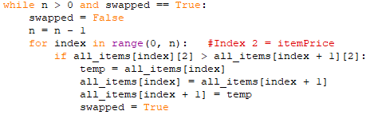
As well as selection, using python allowed me to make use of iteration statements like ‘for’ and ‘while’ loops. An example of this is in my browse menu subroutine when implementing a bubble sort. It sorted all the menu items by price in ascending order before being displayed to the customer. The entire sort was programed under a ‘while’ loop, which continued to execute as long as both ‘n > 0’ and ‘swapped == True’ conditions were true. If either condition became false the loop would terminate. This was beneficial as it meant the menu items were always displayed to the customer in a logical and sorted order, improving user experience.
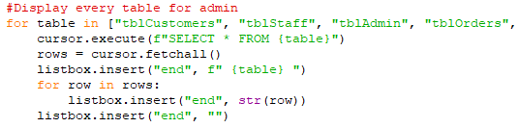
An example of a ‘for’ loop was when displaying all database tables inside the view all databases function. This actually consisted of a nested ‘for’ loop where one iterated through table names and the inner ‘for’ loop iterated through each row within that database table. Eventually, it displayed all records to the admin in a scrollable list box. The ‘for’ loop was suitable for this situation because thee were multiple tables that needed to be processed in the same way. The for loops allowed the program to run exactly 11 times, since I knew in advance there were 11 tables to be processed. It kept the program concise, reduced code repetition and was a more efficient approach.
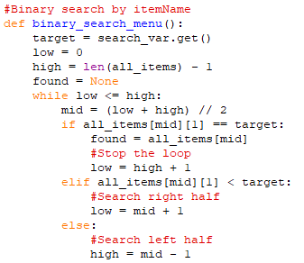
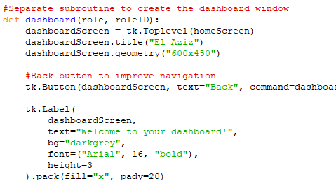
In my program, I was able to use functions to make my program modular, as I organised my code into subroutines to perform a single task. Examples of my functions are create_database(), login(), binary_search_menu() etc. These functions created a modular structure, breaking my program down into smaller and more manageable sections. This made the program easier to develop and debug, as each function could be tested alone. Some functions included parameters such as dashboard() which accepts role and roleID as parameters. This meant that the same function handles customer, staff and admin users, without duplicating the code. This prevented code redundancy and duplication and kept my program concise and organised.

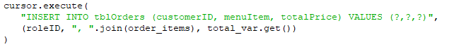
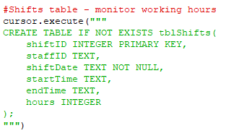
During the software development, I used database tools such as SQL through the use of python’s sqlite3 library to create query and fill out the database. In the create database function, I used ‘CREATE TABLE IF NOT EXISTS’ statements to create and initialise all tables every time to program was ran, without duplicating them. Initially, I had used the ‘CREATE TABLE’ statement, however after encountering issues with table duplication, I update it to the ‘IF NOT EXISTS’ statements to prevent errors. When inserting data, I used queries that consisted of parameters, using ‘?’ as a placeholder for the data to be inserted, protecting the system against harm and maintaining data security. When retrieving data, I used ‘SELECT’ statements with the term ‘WHERE’ to filter records and efficiently retrieve the correct record. It saved time and reduced retrieval time as it would load only the necessary and relevant records in relation to the ‘WHERE’. This made data access efficient and ensured each user only saw their relevant data.

Furthermore, the use of Python allowed me to embed data structures such as lists (arrays) and dictionaries throughout the program to store and manipulate the data in memory. For example, in the browse menu subroutine, the results retrieved from the database are sorted in a list so that the bubble sort algorithm can perform comparisons and swaps based on the index number. In the create order function, I used ‘selections’ and ‘quantities’ dictionaries which mapped each menu item’s ID to its corresponding tkinter checkbox variable and entry bar for its quantity. This made it easy and straightforward to look up the state of any item when calculating the total or submitting an order. Using the dictionaries here were suit bale as it allowed direct searching by the menu item ID, rather than repeating the process through a list to find the correct menu item. This improved the efficiency when calculating a total cost.
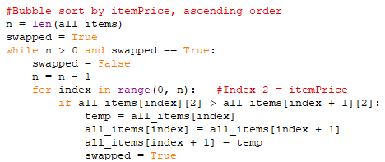

Finally, Python code visualisation tools such as ‘Python Tutor’ were not used during the development of this project. However, they would have been beneficial during the debugging of certain features in functions, such as the sorting algorithms.

Comparison:
During the investigation near the beginning of this project, I observed existing systems, analysing and evaluating them to consider their strengths and weaknesses. This was beneficial as I could learn from the current existing systems weaknesses, and act on them by developing a solution to that weakness, improving my systems performance. Ultimately, I believe my program shared some resemblance with Saray’s Resturant website, however my program mostly looks completely independent of the existing systems I researched, demonstrating uniqueness.
In my investigation, I produced and distributed survey to current El Aziz customers and workers of their non-digital system, where results showed users were not satisfied. Data highlighted that many customers experienced billing errors due to the reliance of staff workers, customer information was at risk of data breaches due to poor security, and the difficulty of creating orders. This data emphasises the countless issues with their system and highlighted the need for a digital online system for all users of the system. Additionally, I carried out an interview with El Aziz’s owner to gather feedback on their current manual paper based system. From this research, data showed customers were extremely unsatisfied due to the difficulty in navigating and using their system. The data highlighted issues with data security and organisation as current orders and reservations made by real customers were simply written down in a notebook, and kept behind a counter. They expressed the lack of security practices they have, the constant errors in orders and reservations as well as the features they would like their system to have. Features like easy reservation management, easy customisation of orders, and a secure customer database to store customer details safely were identified in the interview as El Aziz’s desired features.
Based on this feedback, I produced a system which combatted such issues by providing solutions for each problem communicated in both the survey and interview. As El Aziz expressed concern for data security, the system requires users to login, with passwords being encrypted which demonstrates security practices and the act of preventing unauthorised account possession. Additionally, the use of SQL, allows all users details to be sorted under their role database, allowing for easy identification and retrieval. The customisation of orders was also incorporated into the system using checkboxes to select items and entry bars to specify item quantity, with the opportunity to deselect and change item quantities. Finally, easy reservation and order management was integrated, through the simple reservation window which gathered user’s entries/inputs, storing to a reservation table within their database. Therefore, staff and admin could view this database and see the active orders and reservations, allowing them to update and delete records when necessary.
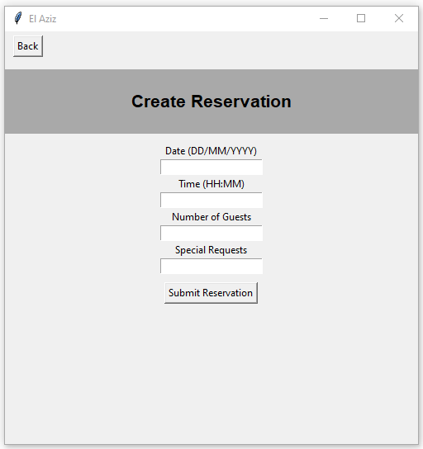
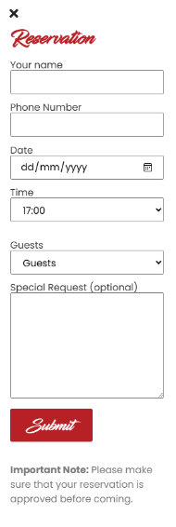
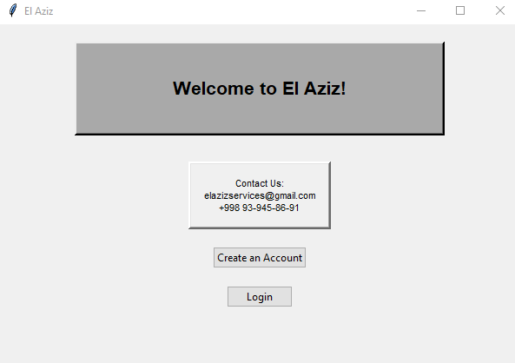
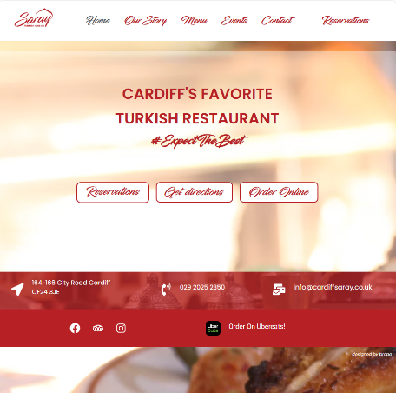
Furthermore, during the investigation I looked at existing systems such as: McDonalds, Saray Restaurant and Toast. Comparing my developed system to these existing systems, I believe my program took the most inspiration from Saray’s website, as El Aziz’s create reservation interface design was like theirs. I simply created a small window that gathered the same information as Saray’s for a reservation, following their structure and data gathered.
Additionally, El Aziz’s home screen page was inspired by Saray’s home page with the organisation of contact information, buttons etc. Although my program lacks the design and colour aspect, my programmed solution shares more similarities with Saray’s in comparison to the other systems I investigated.
However, my system did not take inspiration from McDonalds or Toast, due to poor time management and also my programming abilities. McDonalds’ interface was highly animated and intuitive, which made it very unique and likeable for customers. The animated basket icons, the smooth searching for items and the magnification of items when hovered over, were very considerate features for customers, however were also outside of my programming abilities. With the time and skill I had, it was simply not feasible to both learn and program such features. Additionally, in my investigation I looked at the location feature of McDonalds where you could find the nearest location to you. Admittedly, I did want to incorporate this feature for El Aziz as it could make the identification of their restaurant easier, however due to it being a family owned business and note exactly expanding in the future, this feature seemed pointless as it would only pinpoint one location. Therefore, this feature was not taken into consideration. Finally, due to the ‘View Reports & Analytics’ feature being incomplete, the features and abilities for Toast were not implemented or considered in the programmed solution, however would be useful for future development.

Reflection:
Reflecting on the software development stage, I believe my system solution was successful but could be improved to align with my client’s needs more. The system included good features such as successfully creating orders and reservations as well as being able to view shifts, orders, reservations and any other relevant databases. These features were programmed successfully and efficiently, ensuring the task was clear and could be easily navigated through the GUI design. Personally, these were the foundation of the system, therefore needed to be functional. Other parts of my program provided functionality through the GUI considerations by providing labels and headings which guided the user carefully through their dashboards.
However, the system showed areas without as much functionality. For example, my system was unable to carry out certain features which were preferred by El Aziz, like ordering new stock and viewing their businesses reports and analytics. Without these features, the program lacks the ability to generate data and analytics based on their business performance. In my design, I had produced an intuitive screen which would allow admin to view reports on their restaurants performance, view charts/graphs to see the number of sales, view revenue and profits as well as identify their targets, like their most purchased menu item. Using this information, El Aziz would’ve been able to perform business strategies to increase their sales and income as well as better satisfy their customers. However, I was unable to program this feature due to lack of time and my programming competency. To program this feature, other external libraries like ‘ReportLab’, ‘Pandas’ or ‘NumPy’ would’ve been required. With the small amount of time I had left, it as unfeasible to both learn and program this feature with the limited experience I had. For this reason, I decided to not complete the ‘View Reports & Analytics’ and ‘Order New Stock’ features in my program. I left the features in the user’s dashboard and simply produced a screen alerting the user it would be coming soon, since they are both considered important to the admin, therefore would still be necessary in the program and would be programmed at a later date. Similarly, the ‘Order New Stock’ feature was left incomplete as well as due to the lack of time and need for the ‘Pandas’ library. I wanted to produce a table that would shift table items dynamically, which was simply not feasible with my programming level.
Moreover, some areas of my program both worked correct and incorrectly. For instance, my program was able to sort menu items successfully, however when performing binary searches, it would output the incorrect message to users. During my testing stage, I realised that when users typed in an existing menu item, the program returned the result of being unable to find that item, despite it existing. With this inaccuracy, it limited functionality as the failure to correctly search for an item could frustrate the customers, forcing them to manually search for the item through observation.
To improve my program, I could incorporate message boxes that alert the user of task success or failure, rather than it being told in the terminal. When an order was successfully created, it would simply write ‘Order Successfully Created!’ in Python IDLE terminal, where errors are usually detected. This could be inaccessible and is just not efficient for customers. By using the external ‘messagebox’ python library, I could produce clear message boxes informing users of task result. Additionally, I could improve the system by fixing the current binary search algorithms, ensuring they return the correct result. This would improve customer satisfaction when interacting with the program, leading to better reviews and performance.
Moreover, I could also improve the create order function. Despite their not being visible errors or crashes, adding a simple label informing the user on how to select and specify items correctly, so the total can dynamically update, would make the system more accessible and customer friendly. Although I have written this in the read me file, a simple label underneath the ‘Create Order’ heading could change the way customers interact with the program, ensuring correct use.
Furthermore, my system could’ve been improved by considering the events of double bookings, invalid orders etc. My programmed solution did not prepare for extreme circumstances that could potentially upset customers like double booking. Currently my system only considers the start time of a reservation and not an end time, which can lead to double booking due to potentially overlapping reservation times. For example, if a customer books a reservation for 12:30pm, the system must automatically leave 1 hour and 30 minutes block intervals between the reservation times for that specific table. Otherwise, if a user also books that table for 13:00, the table may still be in use which could confuse customers and create chaos.
Regarding commercial systems features I could have implemented, designing a more customer friendly GUI would’ve improved my solutions efficiency. When observing McDonald’s GUI, I observed their use of bright and vibrant colours, selection of items, adding to basket and other features. These features appeared to also be animated when interacted with, which is customer friendly and appeals to the user. Moreover, developing the payment processing features through a receipt could have also been implemented, since I created a Payments database table, but never used it. Usually a real restaurant system would integrate a form of payment (e.g PayPal) to actually process card transactions when an order is submitted, generate a receipt and update the payment status from ‘Pending’ to ‘Paid’. With this feature, I could handle splitting bills, refunds and staff tips as well which are covered in commercial systems.
Furthermore, with users creating an account with their phone number and email address, a real restaurant system would automatically send confirmation emails or messages providing them with information regarding their reservation. Some systems automatically send reminder messages when approaching the reservation date and time, which reduce the chance of people not showing up or missing their reservation. Using an external library like ‘smtplib’ could’ve handled the sending of emails.
Finally, a standard commercial feature of restaurants are reviews and feedback. After successfully creating and collecting an order, automatically asking customers for a star rating and comment could provide El Aziz with useful feedback and feed into them displaying their rating on their menu or website, to attract more customers.

My Performance:
During this project, I believe I performed well most of the time when developing and producing a solution for El Aziz. I was able to correctly identify my client's needs and form this, produce attainable aims and objectives that helped me create a solution tailored to them. I applied this behaviour throughout the project, maintaining consistency and progress.
During the Software Development, I believe I was able to mostly think logically. However, I still struggled with programming the system as I am not the most experienced in programming. This project forced me to use libraries such as tkinter and sqlite3, which I had never worked with before. However, with SQL being taught for Unit 4, and tkinter self-teaching through GeeksForGeeks, I was able to successfully produce my GUI. Whilst programming, I struggled with the logical aspect of the program when writing code that made sense. An example of this is when I was developing the create order subroutine, when calculating a total. Logically, I knew that the total should update whenever the user changed their selection. However, I struggled to understand that interacting with the tkinter widgets didn’t trigger a recalculation. Therefore, I had to attach the command of updating the total to each checkbox as a parameter so that tkinter knew to call that function every time the checkbox was interacted with. Without this, the total displayed would always remain zero, regardless of user selection. From this experience, I learnt that it was event driven. Moreover, when creating an order, logically you should select the time first and then specify the quantity for the total to update, however my program writes it that you need to specify the item quantity before you select the item for the total to update. Due to not being able to understand that, I wrote this function in an almost inconvenient manner as it is not a logical process.
Furthermore, I had a poor habit of testing in large amounts of code, rather than testing immediately after I programmed a function. As a result of this, I didn’t test enough and struggled to identify errors. When testing, I would test a large subroutine after calling it, which would flag up errors but make it difficult to find the root cause of it. Since I was testing in such large amounts, I didn’t test as much as I should’ve, as if I had tested incrementally, I would’ve performed more tests, identified errors quicker and prevented further issues. Due to this habit, it extended the time taken to complete the programmed solution and caused a few setbacks in completion, which highlighted my weakness and poor approach.
Personally, I acknowledge that this project highlighted my weakness in time management, as I struggled to meet internal deadlines. Towards the beginning of the project, I was very organised and managed my time effectively, completing work ahead of deadlines, making smooth progress. However, as the year went on and I had exams or became busy, I began to struggle with time management as I would prioritise other subjects over the coursework. This led to me making little progress and falling behind in coursework. I began to miss deadlines and hand in work late, however I communicated this all with my teacher who was very understanding of my circumstances at the time. From this, I managed to manage my time better after the very busy periods of my life, dedicating hours to this coursework to ensure it was complete to the best standard. I would use my weekends, holidays and time after college to catch up on coursework as I understood the importance of progress and consistency. Once I had caught up, everything fell into place. Looking back, despite the amount of pressure and stress I was enduring, I still managed to complete the work to a good standard, but having a routine sooner could have prevented this.
As a result of this poor time management, I learnt I had a good work ethic, but it was subject to my conditions. On the average day where I wasn’t busy with other subject commitments I was able to use my time efficiently completing work ahead of deadlines. However, as the year went on and more commitments came up, I began to see a shift in my work ethic, as I would prioritise other subjects and leave coursework behind and late. This demonstrated a poor work ethic, however it was unintentional. As I began to progress through all subjects, I understood the importance of time management and slowly began to create a routine where I could complete multiple assignments for different subjects in a single day. With this routine, and sacrificing a lot of my own free time, I was able to catch up and submit my assignments due. Once I fell behind and caught up once, I remained organised to prevent further issues and maintain progress.
In terms of my programmed solution, I believe my program first the user requirements to an extent. I was completely aware of El Aziz’s preferences, which were identified in the aims and objectives but also emphasises in primary research through observation, survey and interview. My program suits El Aziz as it is a digital system that allows customers to login, create an order or reservation and view them as well as their accounts. Staff can now view their shifts and records from database table’s relevant to their role. For example, a waiter can see the order and reservations table which is standard for them to complete their job. Ultimately the program considers data security and organisation, through features like a login system, encrypted passwords, and database tables being displayed in lists/arrays. It also considers customer experience through the minimal UX design, customisation for orders and reservations and easy navigation. The development of the user interface was crucial to the client, therefore I produced a GUI. The interface consisted of buttons, scrollable lists, checkboxes and entry bars. With these features, it was a lot easier to complete tasks, open new windows and keep track of the user’s stage in using the system. With a simple ‘back’ button for users to return to their dashboard, it optimised the task of closing down each window and locating the preferred window. The user dashboard screens efficiently summarised all tasks into a window, clicking each button to relocate to a new screen where the task would be complete. The features of the GUI make it more intuitive and easier to navigate, as clicking a button is easier and quicker, which keeps users engaged and aware. With large and bold coloured headings, it clearly informed users of each task improving functionality and usability.
Overall, the program is an efficient solution for El Aziz as it highly considers their customers through the interface design, but also by combatting concerns with data security and organisation through better practices integrated into the program.

Evaluation:
In conclusion, I believe my proposed solution to El Aziz’s was successful as it considered the current limitations to their paper based, insecure system, and provided a solution that combatted their issues like staff work overload, data security, system efficiency, etc. Overall, I believe my performance throughout this project has been consistent and I have thoroughly provided an efficient solution, by creating design plans, prototypes, testing plans etc. Each of these modules for this project, contributed to the creation of their new online system. From this project, I have learnt the importance of time management and communication with my client, which is something I take forward with me since the completion of this project.
If I had the chance to complete this project again, I would prioritise my time management and work towards the project every day, as consistency would’ve potentially led to a better program. By constantly working on the project, I could embed it into my routine, whilst working on other subjects. This would also ensure progress was consistent and being made, instead of being left last minute. A more efficient approach would have been to learn how to use different libraries and program them before starting the project, to be more versatile and not let my programming ability limit the potential for a solution. This preparation and learning would equip me with more skills and give me more opportunities when programming the solution. To cause me less problems, I could have tested incrementally, instead of testing all at once when it was complete. A huge issue I faced was writing large sections of code before testing them which meant it was difficult to isolate and identify where the root cause of the error. A better approach would have been testing each function immediately after writing it, which would have caught errors earlier on make it easier to fix.
However, this project has taught me the importance of time management and now I know how I can avoid encountering these problems again as I have learnt from this experience.

